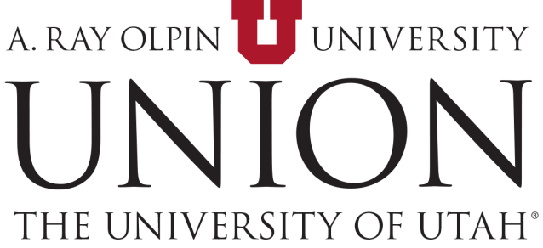

Union Building Alcohol Application

Short description of the event…..in Crimson View. Chartwells will serve all food, beverages, and alcohol service.

Guidelines for Service of Alcohol in the A. Ray Olpin Union
In an effort to better serve the diverse populations that utilize the University of Utah A. Ray Olpin Union, the Union Administration proposes this alcohol policy. The general rule is that alcohol may not be served in University buildings. Notwithstanding this general rule, alcohol service may be permitted under the following circumstances, more fully set forth below:
ADDITIONAL REQUIREMENTS: PLEASE ACKNOWLEDGE BY CHECKING EACH BOX.
- All alcohol service and consumption must comply with Utah state liquor laws.

- During the event, the event space must not be open to the public. It must be available only to your invited guests.

- Employees of the University may not serve any alcoholic beverages to any guest of your event.

- There may be no charge of any kind for alcoholic beverages served at the event. Cash bars are prohibited and no part of any ticket, admission, or registration proceeds collected from those attending the event may be used to purchase alcohol for the event.

- The University reserves the right to end alcohol service and/or the event at any time if we determine that any of the terms and conditions contained in this document have not been completely and fully complied with or if we determine at any time that any problems are arising in connection with the serving of alcohol at the event.

- The University Unit hosting the event must ensure that alcohol is not served to minors.

- This event is not part of a University business meeting and it takes place outside of University business hours (except invitation-only museum exhibit openings, which are allowed during University business hours).

- No legislatively appropriated funds, funds from research grants or contracts, or tuition or fees (usually, but not limited to, funds 1001, 2500, 5000, or 6100) will be used to purchase the alcohol.

- No alcohol to be served at the event was donated by members of the alcoholic beverage industry.

- A $50 alcohol application fee will be assessed and added to the reservation.

These guidelines and this policy only pertain to the Crimson View in the Union. Crimson View is removed from regular flow of student traffic and access is easily regulated. Alcohol is not permitted anywhere else in the building under any circumstances.
Following is a more detailed set of guidelines:
- Approval from cognizant Vice President
The cognizant Vice President must approve requests for alcohol service in buildings over which such Vice President has authority. The University entity working with a third party desiring to serve alcohol at the Union should fill out the form
and present this form to the cognizant Vice President for approval.

- Compliance with State Alcohol Laws and Assumption of Liability
The third-party lessee must agree to comply with all Utah laws regarding the service and consumption of liquor, including applying for and obtaining a single event permit when necessary. This provision should be included in the rental agreement. The third-party must also agree to assume liability for and claims resulting from the service or consumption of alcohol at the event.

- Building/Spaces Must be Rented
The Crimson View must be rented to a third party who is sponsoring the event
in the University building. No University entities or departments may rent or host events in the
Union at which alcohol is served.

- The Reserved Spaces Must be Closed to the General Public
The reserved spaces may be available only to guests during the event at which alcohol is served.

- Participants May Not Consist Primarily of University Employees
The intent of these guidelines is to permit alcohol consumption at certain events directed to non-university employees. It is not to permit alcohol consumption on University premises for departmental or organizational parties or other events that consist primarily of University employees. “Primarily” for these purposes usually means at least 50% of the attendees are not University employees or students but that limitation does not apply when the principal purpose of the event is development or cultivation of donors. Although a University employee may rent the Crimson View or Student Lounge for a purely personal event, such as a wedding reception, a University employee may not rent a facility for the purpose of hosting a party or other function that will consist primarily of University employees.

- No Minor Student May Attend the Event
It is important to ensure that minor students do not attend events at which alcohol is served, and that such events do not take place at times when students will be in the general vicinity of the event, when the Union is involved in the planning of the event. The prohibition regarding minors is not intended to prevent minor family members or other minor guests from attending events such as wedding receptions or other events sponsored and planned solely by private individuals.
- No Use of State Funds
No legislatively appropriated (Ledger One) funds may be used to purchase alcoholic beverages.

- Cash Bars Limited
Cash bars are generally prohibited. This prohibition includes any charge for an event at which alcoholic beverages are provided as part of the price of admission. If there is an admission charge for an event, alcoholic beverages may be served only if the alcoholic beverage or the funds used to purchase them are donated or purchased with funds other than the admission proceeds. Limited exceptions may be granted on an individual basis by the cognizant Vice President if the event sponsor obtains a single event permit from the Utah Department of Alcoholic Beverage Control.

- The Contracted Caterer (Chartwells Dining Services) Must be the ONLY ENTITY That SERVES the Alcohol at the Reserved Event.

- A $50 application fee will be assessed and added to the reservation.

REQUEST FOR PERMISSION TO SERVE ALCOHOL IN THE UNIVERSITY UNION
NAME OF LESSEE:
COGNIZANT VICE PRESIDENT: Lori McDonald
Room: Crimson View
COMPLIANCE WITH GUIDELINES (see first paragraph). Check each point to signify agreement.
CERTIFICATION BY APPLICANT: I certify that I have reviewed the Guidelines for Service of Alcohol in the Union Building and that, except as specifically noted above, this request and the described activities comply with those guidelines.

Lessee Signature Lesee (Printed) Date

Branden Dalley
Union Director Signature Union Director (Printed) Date

Lori McDonald
Cognizant Vice President Signature Cognizant Vice President (Printed) Date

